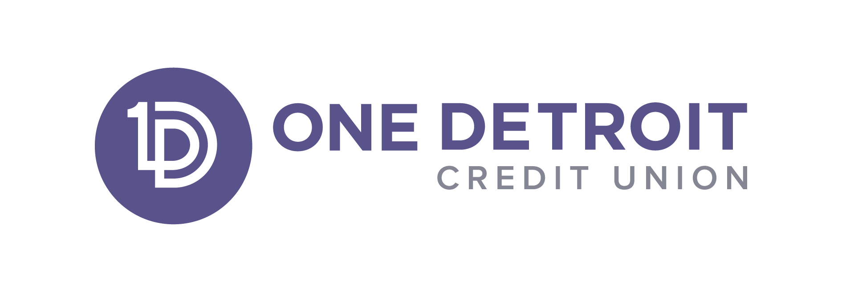

As a reminder you gave your consent to authorize One Detroit Credit Union to pay ATM and one-time debit card transactions on account mentioned above when there are insufficient funds available to cover the transaction. Your optional overdraft privilege level is based on your direct deposits into your checking account; it has been automatically applied to your account.

Members with total direct deposits of $400-$799.99 per month will qualify for Courtesy Pay (Overdraft Privilege) protection up to $250. Members with total direct deposits of $800 or more per month qualify for Courtesy Pay (Overdraft Privilege) protection up to $500.

You have the right to revoke this optional overdraft protection any time by one of the following methods:

- Calling us at 313-965-8640,
- Completing the opt out form located at the bottom of the webpage
Opt Out Form
- Emailing us at Contactcenter@onedetroitcu.org with your request to opt out of the overdraft privilege.

For information about additional overdraft protection options and fee associated with the overdraft protection we offer please visit this link Overdraft Protection Services .

One Detroit Credit Union
www.onedetroitcu.org

